Code commit using HTTPS connection

Step 1: Create an IAM user and grant the necessary permissions to access CodeCommit. Then, generate the HTTPS credentials in the Security tab.

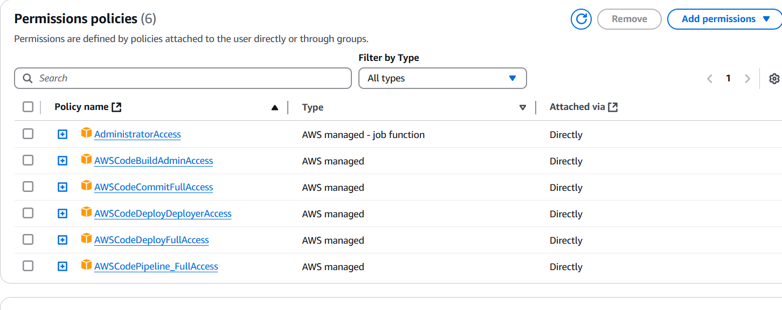

Step 2:

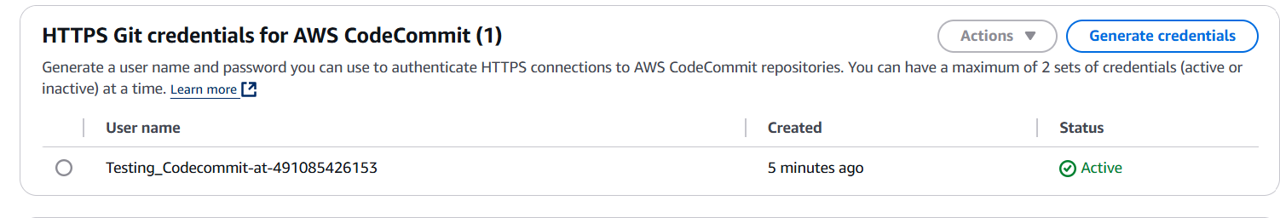

Step 3: Open the code commit

Open Code Commit, enter the repository name and description, and create the repository.

Now they no providing the services access for new customers

Githup to codecommit

Cloning the code commit repo in our local computer, After that copy the github https connection in our local computer

First step:

**Git clone** aws https connectiton url need to give in our local computer

Step 2

Go to the GitHub and copy the https of the GitHub repo and enter in the local computer after entering the codecommit url

https:

<https://github.com/Charli00/Devops.git>

Step3:

Push to codecommit

Copy the codecommit https url then type the command

Git push codecommit https url